**Brooklyn torah gazette**

**For parshas beshallach 5780**

Volume 4, Issue 22 (Whole Number 174) 13 Shevat 5780/ February 8, 2020

**Printed L’illuy nishmas Nechama bas R’ Noach, a”h**

For a free subscription, please forward your request to [***keren18@juno.com***](mailto:keren18@juno.com)

**The Proper Response**

**And Attitude of Jews**

**Towards Our Governent**

**By Daniel Keren**

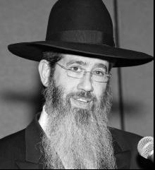

**Rabbi Dovid Goldwasser**

Last week, Hakhel, a Flatbush-based organization dedicated towards promoting a greater awareness of Torah-true values in our community organized a half-day Yarchei Kalleh event for those in Brookly who were off work because of the legal holiday of Martin Luther King Jr.’s Birthday. The program was held at the Agudath Israel of Madison.

One of the featured speakers Rabbi Dovid Goldwasser, Rav of Congregation Bnai Yitzchok in Flatbsh and internationally renowned Maggid Shiur. He spoke on the topic of “Halachic Perspectives for Current Times.”

He recalled that 1918 Czar Nicolas II, the last monarch of Russia was assassinated after a year of imprisonment following his forced abdication from the throne after the Russian Revolution. Many Jews came into the shul where the Rogatchover Gaon (Rabbi Yosef Rosen, zt”l) was (either davening or learning) and began dancing with great joy.

**The Rogatchover Disagreed and Began to Cry**

When the Rogatchover Gaon found out the cause for the rejoicing he began to cry. He explained when questioned by the perplexed celebrants that it was good for one to have a respect for one’s government based on fear as stated by Rabbi Hanina, the Deputy Kohen Gadol in Pirkei Avos 3:2).

The Satmar Rebbe (Rabbi Yoel Teitelbaum, zt”l) was not known to fear anyone. Yet whenever he met a government leader, he would bow his head as a sign of respect in accordance with the dictates of the Torah to show such respect. Even Moshe Rabbeinu was commanded by G-d to speak to Pharaoh with derech eretz (respect.)

Rav Avigdor Miller, zt”l, once recited on Shabbos a prayer on behalf of the American government specifically citing the President (Richard Nixon) and Vice President (Spiro Agnew) of the United States. Rav Miller said that Rav Yisroel Salanter, who had founded the mussar (the study of ethical behavior) movement in Europe in the 19th Century had instructed that this prayer for the welfare of the government be recited.

**Life and the Government Aren’t Perfect**

Rabbi Goldwasser admitted that often life and the government aren’t perfect. But we as Yidden have an obligation to have a strong sense of hakoras hatov (gratitude) for the government and to pray to Hakodesh Baruch Hu (the Holy One blessed be He) to continue blessing our leaders that they should be successful (i.e. do that which is good, such as protecting its citizens, including the Jews.)

If there is a lack of respect for the government, Rabbi Goldwasser said that this is ultimately not good for us Jews as individuals or as a Jewish community. Rav Elchanon Wasserman, hy”d, said that unfortunately, sometimes the political leaders are guided by their subjects [or the electorate] and this is not always beneficial to the nation.

The world is like a mirror. When we are careful with the mitzvahs we are commanded by Hashem to perform, this would be reflected in the world around us. If no Jew would ever lose his temper and thereby never strike or insult another Jew, this would be reflected in the day-to-day mirrors of our lives by the fact that no goy (non-Jew) would be granted the power by G-d to strike or insult a single Jew in this world.

If we see that Jews are suffering from the non-Jews, we should understand that this is a message [or wake-up call} from Hashem that we have to examine our actions and mitzvah observance and make a serious effort to improve our own kesher (connection) to the Ribono shel Olam.

Rav Eytan Feiner from Knesseth Israel (the White Shul) in Far Rockaway once asked Rav Chaim Kanievski if his shul should employ an armed guard. Rav Kanievski replied that if there is no talking in the shul during times of davening, there is no need for an armed guard. On an interesting point regarding the campaign to promote no-talking in shul during services, Rabbi Goldwasser pointed out that there was a lack of clarity regarding whether or not that including the prohibition of saying yasher koach (congratulations) to a fellow congregant who returned to his seat from the bima after his aliyah during the Torah reading.

*Reprinted from the July 31, 2020 edition of the Jewish Connection.*

**Attorney General William Barr Blames Anti-Semitism on ‘Militant Progressivism’**

**By Ben Sales**

**Jewish Telegraph Agency**

**Remarks come in meeting with**

**Orthodox Jewish leaders in Brooklyn**

In a meeting Tuesday with Orthodox Jewish leaders in Brooklyn, U.S. Attorney General William Barr pledged to track and prosecute hate crimes more aggressively on the federal level while also blaming the rise of anti-Semitism on what he called “militant progressivism.”

Barr’s concrete proposals for stopping anti-Semitism included an enhanced system for reporting hate crimes, as well as better tracking of white supremacists on social media. He pledged that the Trump administration and his Justice Department would have “zero tolerance” for anti-Semitism, which he said “strikes at the very core of what this country is about.”

He rejected the idea that President Donald Trump bore any of the blame for the national rise in anti-Semitism, a notion raised by one of the participants. Instead he put the blame on the left.

“Unfortunately anti-Semitism is a very ancient disease, and historically the right wing has been the main perpetrators of it, but we also see progressivism and the left wing now participating in a variety of ways,” Barr said, adding later, “They demonize their opponents, people who disagree with them and resist, or don’t fit into the mold or don’t do the kinds of things that they think are the best way of organizing society.”

[](https://static.timesofisrael.com/jewishstanddev/uploads/2020/01/barr1.jpg)

**U.S. Attorney General William Barr greets Orthodox leaders in Brooklyn prior to meeting with them, Jan. 28, 2020. (Ben Sales)**

He also said, “I don’t think that comes from the president, frankly. I think that comes from this militant progressivism.”

The meeting follows two violent attacks on nearby Orthodox communities in December – a [shooting](https://www.jta.org/quick-reads/6-killed-in-shootout-at-jersey-city-kosher-supermarket-including-a-policeman-and-3-civilians) at a kosher supermarket in Jersey City, New Jersey, that killed four and a [stabbing](https://www.jta.org/2019/12/29/united-states/after-a-machete-stabbing-on-hanukkah-monseys-orthodox-jews-are-defiant-but-searching-for-answers) at a Hanukkah party in the upstate suburb of Monsey that left five injured.

Also in the past few months, Orthodox Jews in Brooklyn have been the targets of frequent harassment and assaults. According to the New York Police Department, anti-Semitic incidents through September [rose 50 percent](https://www.jta.org/2019/10/04/united-states/anti-semitic-hate-crimes-in-nyc-have-risen-significantly-in-2019) over the previous year and made up a majority of reported hate crimes in the city.

Barr outlined several steps that the Justice Department is taking to prevent anti-Semitism.

The attorney general is instructing every U.S. attorney to establish processes and an address in their office for reporting hate crimes and staying in touch with local Jewish leaders, as well as a system to determine whether those crimes should be addressed on the federal or state level. He also wants to define which ostensibly nonviolent symbols or actions could signal a physical threat toward Jews — akin to cross-burning as a racist symbol.

And Barr wants the department to watch out for antisocial or white supremacist threats on social media, similar to how it tracks jihadists. Previously, the Trump administration [scaled back](https://www.jta.org/2019/10/08/united-states/how-pittsburgh-changed-the-way-american-jews-think-about-security) some efforts to track white supremacists online.

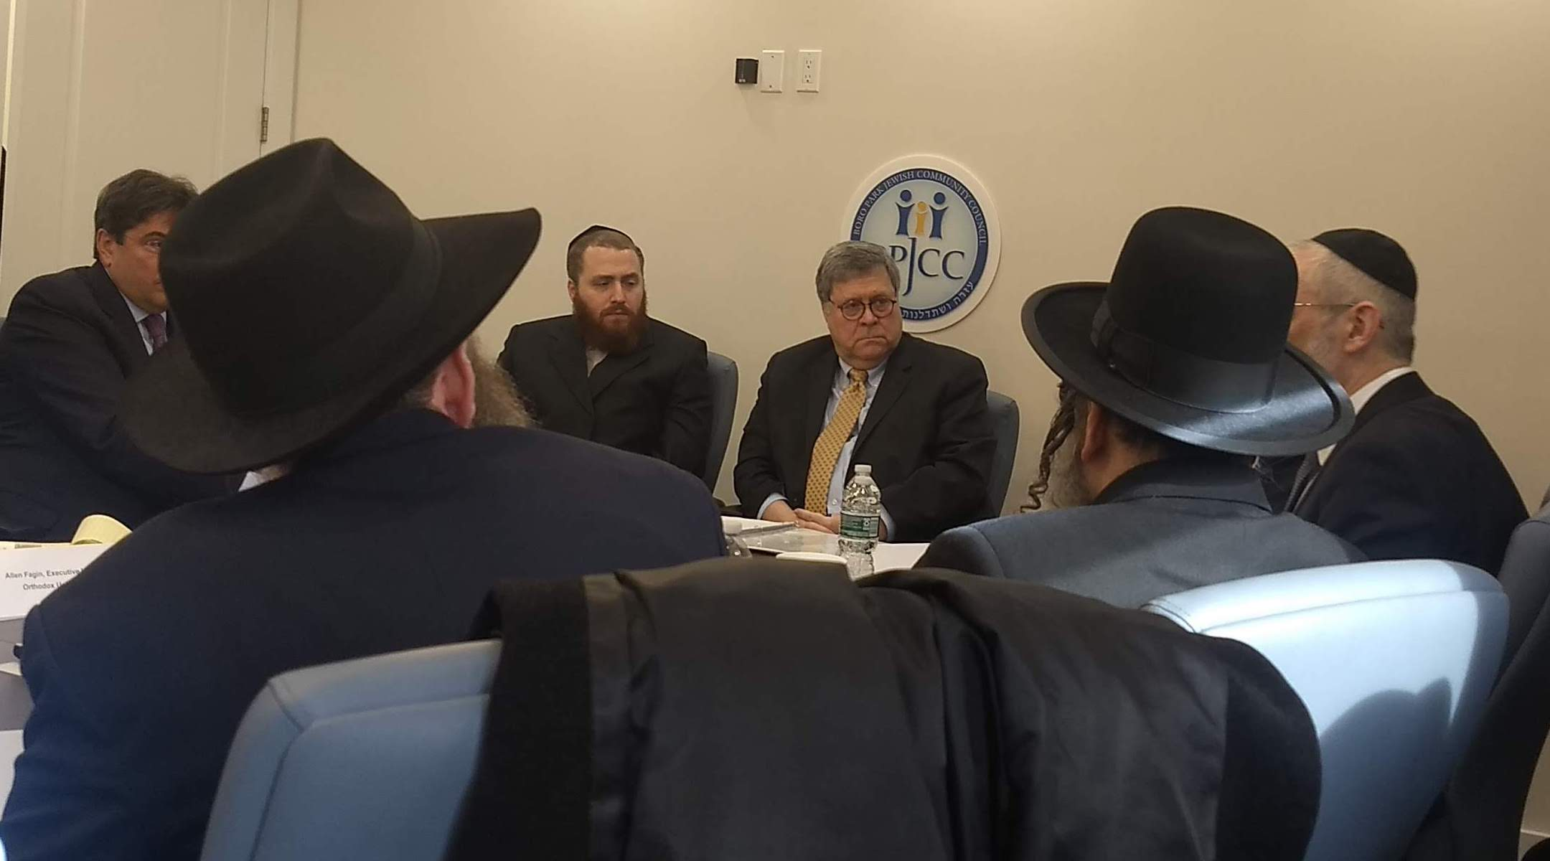

**Barr speaks to Orthodox leaders in Brooklyn, Jan. 28, 2020. His indictment of progressive values struck a chord with the largely traditionalist group. (Ben Sales)**

Barr also pledged to prosecute more hate crimes on the federal level. He announced that the Justice Department has charged [Tiffany Harris](https://www.jta.org/2020/01/07/united-states/as-anti-semitism-rises-a-new-ny-law-abolishing-bail-for-low-level-crime-comes-under-attack), a Brooklyn woman who made headlines for slapping three Jewish women and then being released, with hate crimes.

“These are the kinds of cases that maybe in the past would have been treated locally, but I think it’s important for the federal government to plant its flag,” he said. “We will move aggressively when we see this kind of activity.”

Barr’s indictment of progressive values struck a chord with the largely traditionalist group of leaders.

“I personally appreciated very much what he said when he spoke about the larger moral climate and the values American society has always embraced, and how are they being undermined today in a progressive new world,” said Rabbi David Zwiebel, executive vice president of Agudath Israel of America, an umbrella haredi, or ultra-Orthodox, group.

The participants in the meeting thanked Barr for coming to Borough Park and praised his proposed changes.

They also called for increased federal security funding for houses of worship, as well as an increased police presence around synagogues. In December, Senate Minority Leader Chuck Schumer, D-N.Y., called for the [quadrupling](https://www.jta.org/quick-reads/chuck-schumer-calls-to-quadruple-funding-for-federal-security-grants-for-nonprofits) of federal grants to nonprofit institutions at risk of terrorism, like synagogues, to $360 million from $90 million.

“Longer range, we’d like to see the Department of Justice really get behind a much greater development of resources to community police,” said Allen Fagin, the executive vice president of the Orthodox Union, a major Orthodox group. “The Department of Justice is in control of hundreds of millions of dollars in grants to local police authorities. We need to see some of that money devoted to community policing in Jewish neighborhoods.”

The Orthodox leaders at the meeting also decried [proposed regulations](https://www.jta.org/2019/08/13/united-states/ny-orthodox-schools-are-fighting-a-proposal-that-would-force-them-to-increase-secular-education) in New York state that would force Orthodox yeshivas to teach more secular subjects like math, science and English.

Barr claimed that in the near future, supporters of such efforts will “try to equate traditional Judeo-Christian thought and doctrine as somehow related to hate.” He spoke out multiple times in support of school choice and said his office would look into those educational regulations. Barr also said that the Justice Department would look into local efforts to use zoning laws to prevent Orthodox Jewish communities from [expanding into suburban towns](https://www.jta.org/2017/08/18/united-states/new-yorks-orthodox-jews-are-expanding-into-these-towns-and-some-residents-arent-happy) in New York and New Jersey.

“What scares me the most is when I see the spiritual hollowing out that’s been occurring in the Western world, and some of it here in the United States. One worries when barbarism is right below the surface,” Barr said.

“There should be separation of church and state, obviously, but we’ve always recognized that religion plays an important role in making sure that a pluralistic society like ours can move forward without these kinds of hatred and violence.”

*Reprinted from the January 28, 2020 dispatch of the JTA (Jewish Telegraphic Agency) published in the Jewish Standard of New Jersey.*

**Morocco Opens $1.5 Million Center Dedicated to Jewish Culture in City of Essaouira**

**By Josefin Dolsten**

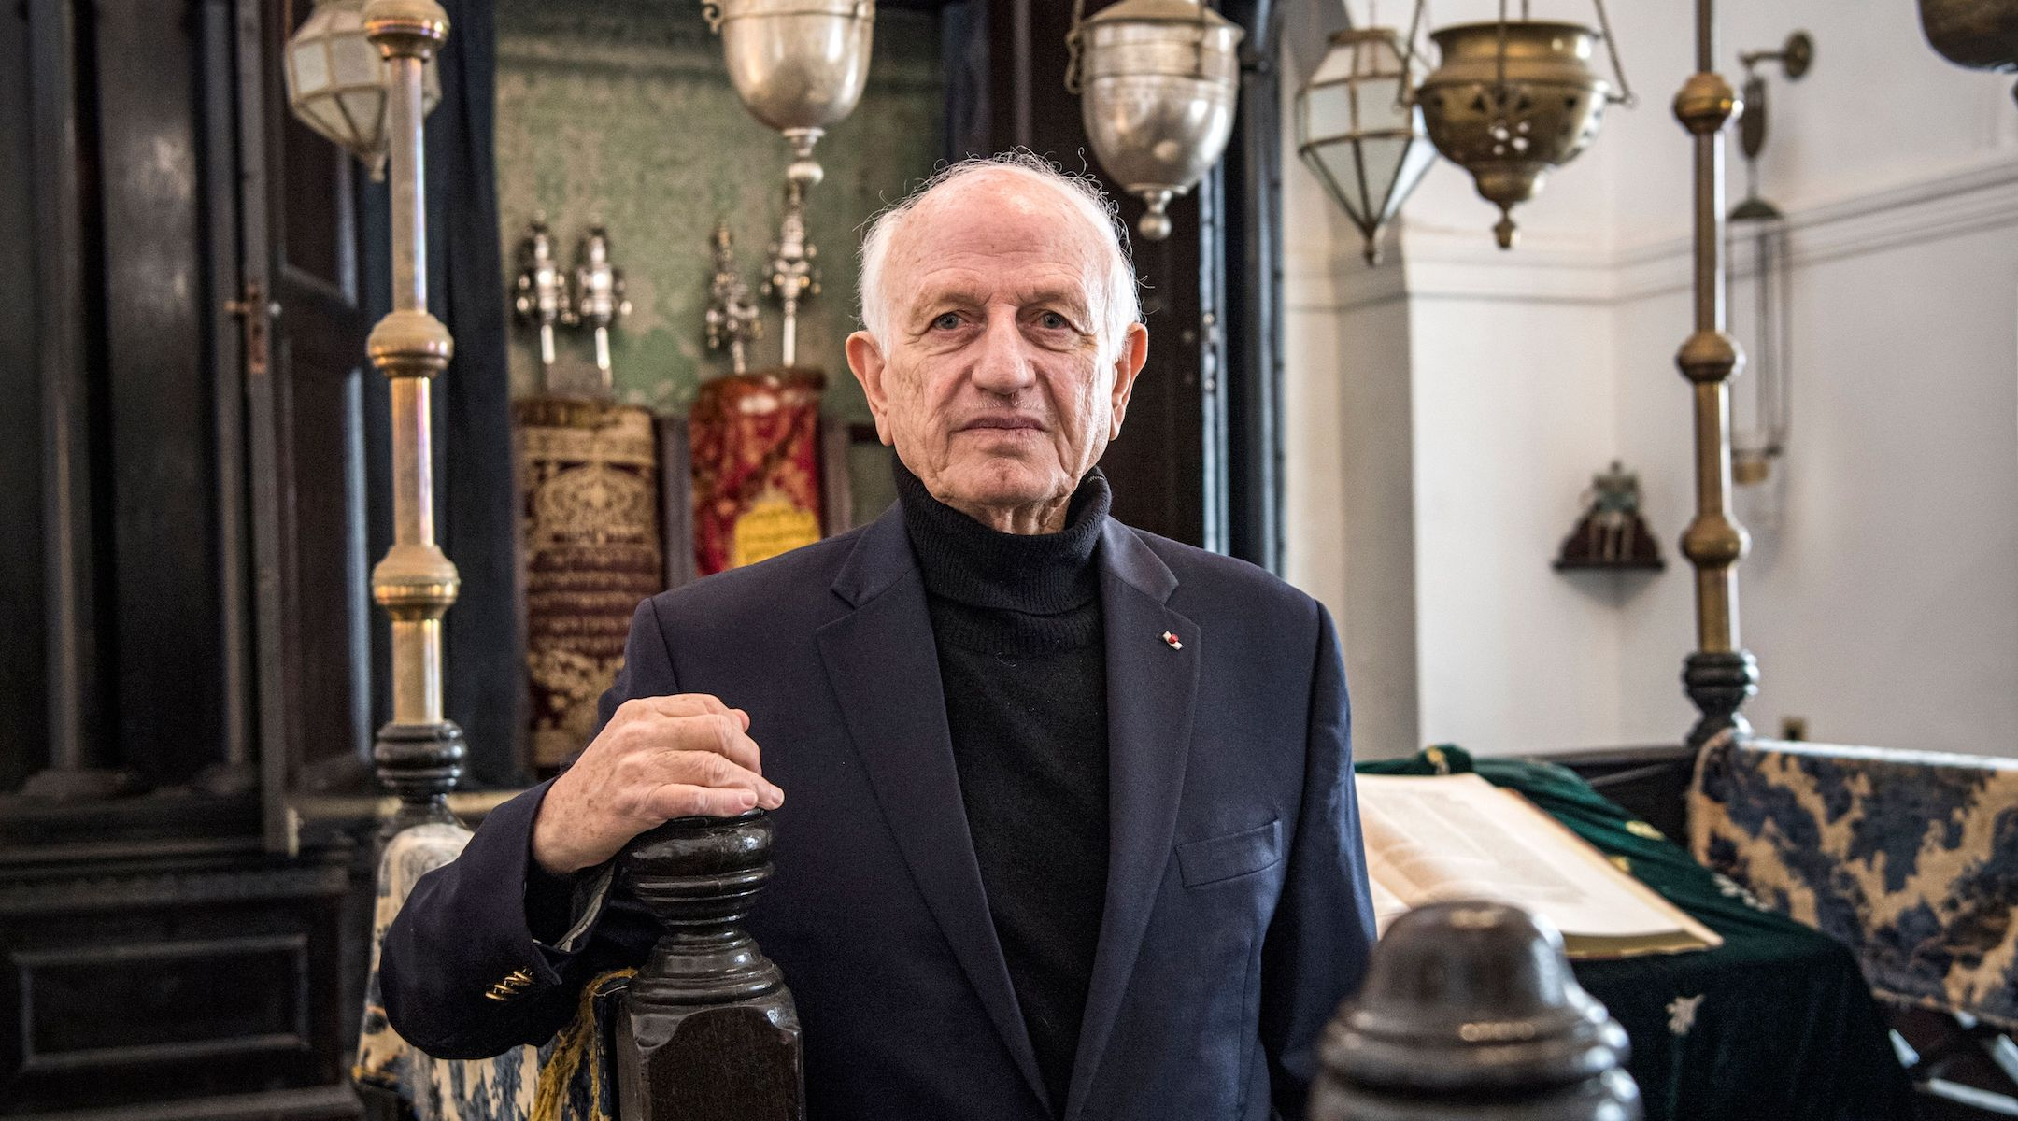

**Andre Azoulay, adviser to the Moroccan king, poses for a picture at the Bayt Dakira Jewish museum in Essaouira, Morocco, Dec. 14, 2019. (Fadel Senna/AFP via Getty Images)**

([JTA](http://jta.org/)) — Morocco’s king has inaugurated a $1.5 million center dedicated to Jewish culture in the city of Essaouira.

Last week, King Mohammed VI attended the inauguration for Bayt Dakira, which means House of Memory in Arabic.

The port city was formerly home to a large population of Jews, who at one point making up 40 percent of the population. Most Jews fled Morocco because of the hostility they felt following the establishment of Israel in 1948 and in decades after.

Today [less than a handful of Jews](https://www.abc.net.au/news/2018-06-20/the-exodus-of-moroccan-jewish-community-to-israel/9879638) reside in the city.

The center is located in a restored home that houses a small synagogue and includes a museum, research center and space that will host cultural events. The project was created by Andre Azoulay, a France-educated Moroccan Jew who serves as a senior adviser to the king.

Most of the funding came from the Moroccan government, with a quarter coming from private donors.

Among a number of high-profile Moroccan Jews who attended the event and a dinner with the king afterwards were Azoulay and his daughter, Audrey, who serves as the director-general of the United Nations Educational, Scientific and Cultural Organization, or UNESCO, Moroccan Jewish comedian [Gad Elmaleh](https://www.jta.org/2017/05/12/culture/watch-this-moroccan-jewish-comedian-skewer-trumps-travel-ban) and the chief rabbi of Geneva, Switzerland Izhak Dayan.

[Under King Mohammed VI, Morocco has made efforts to preserve Jewish sites.](https://www.jta.org/2013/05/13/global/moroccan-king-funding-preservation-of-cape-verde-jewish-heritage-but-to-what-end) The country is home to a Jewish museum in Casablanca, which along with an adjacent synagogue [was renovated and rededicated in 2016](https://www.jta.org/2016/12/20/israel/moroccos-king-attends-rededication-of-casablanca-synagogue-and-jewish-museum).

Jason Guberman, the director of the American Sephardi Federation, which is serving as a partner organization to Bayit Dakira, praised the king for his efforts.

“On the one hand it has the museum and it’s going to be about studying the past, but it’s also very much about doing events and bringing people to Essaouira today,” Guberman told the Jewish Telegraphic Agency. “It says a lot about Morocco’s future, the fact that the king would come to open up a center like this.”

The American Sephardi Federation also sent a letter together with the Conference of Presidents of Major American Jewish Organizations to the king of Morocco thanking him for opening the center.

*Reprinted from the January 24, 2020 dispatch of the JTA (Jewish Telegraphic Agency.*

**Thoughts that Count**

How can I alone bear your weight, your burden and your strife? (Deut. 1:12)

As Rashi explains, the "burden" referred to by Moses was the heretics among the Jewish people.

Commented Rabbi Nachman of Breslov: "The heaviest burden a person can bear is apostasy. The heart of a Jew who believes in G-d is calm and tranquil, while the heretic must constantly contend with the weight of his doubts and troubling thoughts."

*Reprinted from the Issue #351 of L’Chaim Weekly (Parashat Shemos 5755/1994)*

**The Shmuz onParshas B-shallach**

# **People Believe What**

# **They Want to Believe**

**By Rabbi Bentzion Shafier**

**Founder of TheSmuz.com**

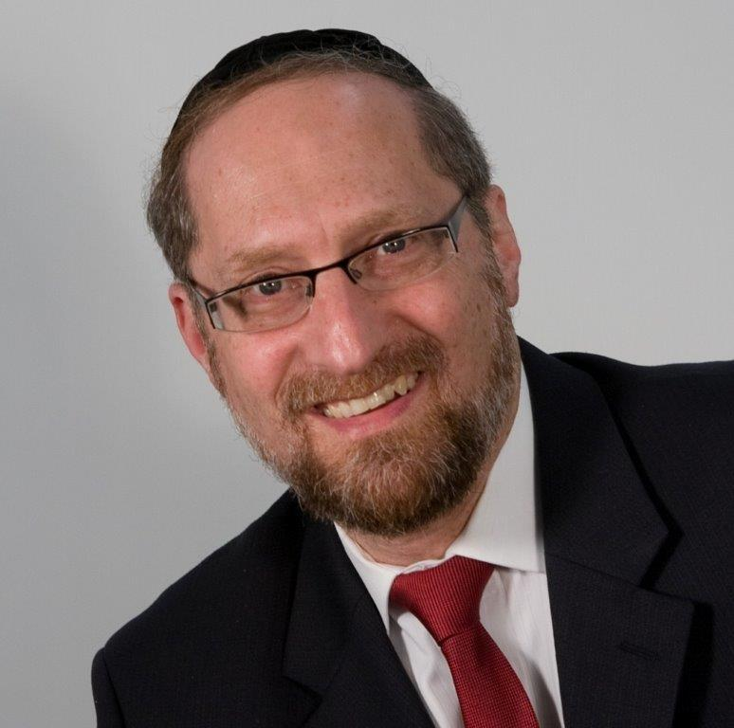

“And Moshe stretched out his hand over the sea, and HASHEM moved the sea with a strong eastern wind all the night, and He turned the sea to damp land and the water split.” — Shemos 14:21

Mitzrayim, the nation that bragged that no slave had ever escaped its land, stood by helplessly as the Chosen Nation triumphantly left. The Jewish people, now some three million strong, marched through the desert surrounded on all sides by clouds that protected them and led by a pillar of cloud that lit up the night as if it was day.

Yet even at this moment, Pharaoh sent spies along to follow them. After three days, his agents reported back that the Jews had veered off course. Pharaoh called out to his people, “Let us reclaim that which is ours,” and he led them in pursuit.

beliefs.

## How could the Mitzrim possibly believe the wind split the sea?

When the Mitzrim arrived on the scene, the Jews were camped out against the Yam Suf. With their backs against the sea and no place to move, it seemed certain that the Mitzrim would recapture them. At that moment, the cloud of fire that led the Jews through the desert moved to the back of the camp and stopped the Mitzrim from advancing. That entire night, both camps stood in their places, separated by the Clouds of Glory.

The Ramban tells us that during the night, an eastern wind began to blow. This was the wind that split the sea. At first, it made small indentations in the sea, but as the night wore on, the wind became stronger, and those small indentations grew in size and depth until the sea itself was split into twelve distinct pathways – ready for each Shevet to cross in its own channel.

The Ramban explains that HASHEM split the sea specifically with an eastern wind “so that it would appear as if the wind split the sea into partitions.” Even though the wind can’t possibly split the sea, much less split it into twelve separate partitions, nevertheless, because of their great desire to harm the Jews, the Mitzrim “pegged it on a natural cause.” It was just the wind, nothing more.

How could the Mitzrim possibly believe the wind split the sea?

This Ramban is very difficult to understand. How could the Mitzrim possibly pin the splitting of the sea on the wind? They were intelligent, thinking people. They, as everyone else, clearly understood that it couldn’t possibly be a natural occurrence. How is it possible that they accepted this sham – that the wind split the sea?

**Understanding Free Will**

The answer to this question is predicated upon understanding the concept of free will. Free will doesn’t mean a **theoretical** ability to do good or bad. It is the practical ability where either side is possible. When a person can just as easily turn to the bad as to the good, then it is his decision to choose.

As an illustration, do you have free will to put your hand in a fire? In theory, you do. You could do it. But you never would. It is damaging. It is foolish. So, while in **theory** you have free will to do it, on a **practical** level, you don’t.

**Creating Man**

Chazal tell us that HASHEM created man to give him the opportunity to shape himself into what he would be for eternity. That molding of the person is accomplished by choosing that which is good and proper and avoiding that which is wrong and evil. By making these choices, man is given the ability to form himself.

To give man an even playing field, HASHEM took the sechel – that pure, brilliant part of me – and inserted it into a body filled with drives, passions, and hungers. Now the two parts of me are integrated. I don’t want only what is good and proper and noble. I also desire and hunger for many other things. My choice of doing only good is no longer so simple.

However, if HASHEM created man only out of these two parts – the sechel and the guf – the purpose of creation would never have been met. The wisdom of man is so great that it would be almost impossible for him to sin. Since every sin damages me and every mitzvah makes me into a bigger, better person, my natural intelligence wouldn’t allow me to sin, no matter how tempted I might be. I would clearly recognize it as damaging to me. Much like putting my hand into a fire, in theory I would have free will to do it, but on a practical level, I wouldn’t.

Imagination – its role and function

Therefore, HASHEM added one more component to the human: **imagination**. Imagination is the creative ability to form a mental picture and sense it so vividly, so graphically, it is as if it is real. Ask anyone who has ever cried while reading a novel whether imagination isn’t a powerful force.

Now armed with this force, man can create fanciful worlds at his will and actually believe them. If man wishes to turn to evil, he can create rationales to make these ways sound noble and proper – at least enough to fool himself. Armed with imagination, man truly has free will. If he wishes he can do what is right, or if he wishes, he can turn to wickedness, and even his brilliant intellect won’t prevent him. With imagination, he is capable of creating entire philosophies to explain how the behavior he desires is righteous, correct, and appropriate. **Now** man has free will.

**People Believe What They Want to Believe**

The reality is that people don’t necessarily believe that which is factual, proven and true; they believe what they want to believe. And while there are countless examples of this, one of the greatest manifestations is the Mitzrim following the Jews into the Yam.

Despite living through the makkos, despite seeing the Yam split into sections, they didn’t believe it was a miracle. They attributed it to the wind because that is what they wanted to believe.

Understanding this can help us comprehend how people can stare at things so obvious and true and yet deny their very existence. There are many reasons why a person might not want to accept what his mind tells him is true. He has to be able to put away all other issues and focus on this one question: what do I think is the truth? Forget the consequences. Forget my agenda. Is there a Creator of this world? Logic will bring them to see the hand of G-d. However, if he isn’t honest, then nothing in the world will convince him, not the greatest miracles, and not even the splitting of the Yam Suf itself.

*Reprinted from this week’s website on TheShmuz.com This is an excerpt from the [Shmuz on the Parsha book](https://theshmuz.com/product/shmuz-on-the-parsha-book/).*

**The Significant Lesson of the Manna to the Jewish People**

**From the Talks of the Lubavitcher Rebbe**

**Rabbi Menachem Mendel Schneerson, Zt”l**

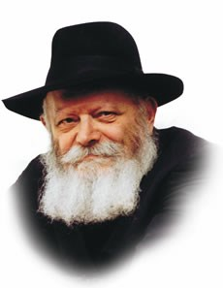

This week's Torah portion, B'shalach, speaks about the manna eaten by the Children of Israel during their forty-year sojourn in the wilderness.

The Torah describes at great length the way it fell from heaven, the manner in which it was gathered, its taste, and how G-d commanded the Jews to collect only one omer (a dry measurement) per person.

"The Children of Israel ate the manna forty years, until they came to an inhabited land," the Torah states. Then, almost as an afterthought, the Torah concludes, "Now, the omer is a tenth part of an epha (a larger ancient dry measurement)."

Biblical commentators ask why this definition of the omer is left for the very end of the chapter. Why wasn't the omer defined the first time it was mentioned? The explanation that it would have interrupted the narrative of events is insufficient.

In order to answer this question, let us first pose a more fundamental one. Why did G-d decree the same portion of manna for every single person?

How is it possible for everyone, young children and adults alike, to be sustained by the exact same amount of food? Aren't a person's nutritional needs directly related to the size of his body?

A similar principle involving a uniform amount of food was applied by our Sages in the prohibition against eating on Yom Kippur.

While it is forbidden to eat or drink anything on that day, a person becomes subject to the greatest punishment when he has eaten an amount equal to "a dried date." This quantity was fixed as the minimum amount of food necessary to sustain life. Again, the size of the person is of no regard.

We see then that there are two distinct types of sustenance: one that is necessary to maintain bodily functions, directly related to the size of the individual and the organ itself, and another, more fundamental type of sustenance, that is required to sustain the person's life-force. This amount does not change from person to person or from organ to organ -- it is exactly the same for every human being.

This phenomenon stems from the two distinct levels of vitality that emanate from the soul to the physical body.

One type of energy is individualized according to the needs of the particular organism it sustains, and the other is a more generalized life-force that keeps the person alive on the most fundamental level. This latter type is always the same for everyone.

The manna -- "bread from Heaven" -- embodied both of these qualities:

On the one hand, a uniform amount was sufficient for every human being, yet at the same time, it was able to supply the person's individual needs as well.

This unique distinction is alluded to in the words "the omer is a tenth part of an epha" -- the omer of manna is part of a larger, fuller entity.

The manna was not only food in the physical sense, but provided spiritual sustenance, too.

When the Jews' forty years in the desert came to an end, it entailed "weaning" them from their G-dly subsistence and their relearning how to live in a wholly physical world once again -- the reason this point is made at the end of the manna narrative.

*Reprinted from the Issue #351 of L’Chaim Weekly (Parashat Shemos 5755/1994)*

**Rabbi Berel Wein on**

**Parashas Beshalach**

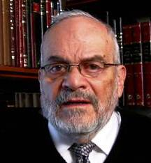

Miracles occur in all sizes and shapes. Some are major, completely aberrational and beyond natural or rational explanation. Other miracles that occur to us daily in our own lives take the form of being natural events and part of the rhythm of society and life. Major miracles command our attention, and as we see in this week's reading of the Torah, even cause us to sing eternal songs that extend through generations of Jewish life till our very day.

Certainly, the splitting of the waters of the sea before the Jewish people, escaping from the Army of the Pharaoh of Egypt, and then for those very waters receding and covering the drowning Egyptian enemy, is a miracle of major importance, and thus remains indelible in the collective memory of the Jewish people. So, Moshe and his sister Miriam lead the Jewish people in song to commemorate this event and to impress upon them the awesome quality of this major miracle.

We are reminded daily in our prayers of this miracle, and the song of Moshe forms an important part of our daily morning prayer service. This type of miracle was repeated when the Jewish people crossed the river Jordan on their entry into the land of Israel after the death of Moshe and at the beginning of the reign of Joshua. This could be termed less of a miracle, than what took place with the Egyptian army, yet it represented the confirmation of the divine will to protect the Jewish people and to enable them to enter, inhabit and settle the land of Israel that would be its eternal homeland over all of the millennia of civilization.

However, the commemoration and memory of the major miracle should also remind us of the so-called minor miracles that occur to us in our daily lives. We are accustomed to everything going right as far as our bodies, social interactions and commercial enterprises are concerned. But it should be obvious that for things to go just right – simply what we call normal life – countless minor miracles must take place. We recite this in our daily prayers as well, and, in fact, we do so three times a day when we acknowledge and thank G-d for these so-called minor miracles that are with us constantly, evening, morning and afternoon.

This ability to recognize and give thanks for the minor miracles that constitute our daily existence stems from the fact that we experienced, in our collective memory, the great miracle that made us a people, and saved us from the destruction that Pharaoh wished to visit upon us. It is this memory of the great miracle that enables us to recognize the so-called minor miracles that we are living through, especially here in the land of Israel, with the return of Jewish sovereignty.

It is important to maintain the ability to recognize and be grateful for the wonders and miracles that the L-rd grants us each and every day of our individual and national lives.

*Reprinted from the Issue #345 of L’Chaim Weekly (Parashat Mikeitz 5755/1994)*

**Thoughts that Count**

*Moses began (ho'il) to explain this law* (Deut. 1:5)

The Hebrew word "ho'il" contains the same letters as "Eliyahu" - an allusion to the time to come when Elijah the Prophet will answer all our difficult questions. Also, the questions posed by the last few generations before Moshiach will be complicated and troublesome; their answer will only be found through the same self-sacrifice that was shown by Pinchas, whom our Sages explain was reincarnated as Elijah the Prophet. (Yalkut Moshe)

*Reprinted from the Issue #351 of L’Chaim Weekly (Parashat Shemos 5755/1994)*

**Rav Avigdor Miller**

**On Standing Firm**

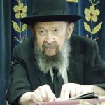

**QUESTION:** In Tanach it states, כי שבע יפול צדיק וקם – A righteous person will fall seven times and he'll get up (Mishlei 24:16). Why does a *tzaddik* have to fall so many times?

**ANSWER:** It states: שבע יפול צדיק וקם — Seven times a *tzadik* falls and he stands up. It means that in the end he remains standing.

Rav Nachman Bresolver in one of his *seforim* relates that when he began his career as an *oived Hashem,* it wasn’t only seven. Sometimes, a hundred times a day he fell down; but he wasn’t discouraged.  Each time he rose again and fought back. And he said, “No, I’m going to remain standing.”

And that’s the career of all righteous people.  They fall and they fall, but in the end they are going to conquer.

Now why should they fall?  And the answer is because if you remain standing easily, then you’re not really standing.  Let’s say you’re able to set up a toy soldier on a place where there’s no wind. That doesn’t mean he’s standing.  If anybody will pass by, then the wind that he creates will knock it down. Standing means *its firm!*

And therefore, for a *tzaddik* to know that he’s וקם – that he’s really standing, he has to fall and fall until finally he’s able to withstand all the ordeals and remain standing.  That’s when you know you’re standing.

So let’s say, if you’ll isolate yourself in a room and you’ll lock the doors and put shutters over the windows and have no contact with anybody in the world and you won’t talk *loshon hara*– it’s a big achievement, but it’s not big enough.  It’s only when you’re in contact with mankind and you’re able to remain standing, then it counts.

And that’s why Hakodosh Boruch Hu gave man a wife because that’s the person he’ll be in contact with most.  אעשה לו עזר כנגדו – and living with a wife, when he remains standing and she remains standing, then it’s a big achievement.

*Reprinted from the January 28, 2020 email of Toras Avigdor adapted from Tape #192.*

**We’re Never Too Busy**

**To Say “Thank You”**

**By Rabbi Eli J. Mansour**

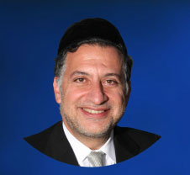

The first section of Parashat Beshalah tells one of the most dramatic stories in the entire Torah – the story of Keri’at Yam Suf, the miracle of the splitting of the sea.  Beneh Yisrael were trapped between the sea and the pursuing Egyptian army, and Hashem miraculously rescued them by splitting the sea, allowing them to cross on dry land.

Toward the beginning of the Parasha, there is one verse which appears to be somewhat out of place, recording an event that seems, at first glance, to pale in comparison to the rest of this section in terms of drama.  The verse tells us that as Beneh Yisrael left Egypt, Moshe took with him the remains of Yosef, in fulfillment of the vow made by Yosef’s brothers to bring his remains out of Egypt so they could be interred in Eretz Yisrael.

But while this Pasuk may strike some as “uninteresting,” the truth is that we have much to learn from this aspect of the Exodus. The Hemdat Yamim (attributed to a student of the Arizal) noted that in telling of Moshe’s efforts to bring Yosef’s remains, the Torah adds the word “Et”:

“Va’yikah Moshe Et Asmot Yosef Imo.”  The word “Et” generally alludes to something in addition to that which is mentioned explicitly in the text.  In this instance, the Hemdat Yamim explains, the Torah alludes to another deceased person whose remains were brought by Moshe out of Egypt – Moshe’s stepmother, Batya.

As we read in Parashat Shemot, Batya – Pharaoh’s daughter – was bathing in the river when she saw an infant floating in a basket.  Recognizing that this was an Israelite child, she took the baby and adopted him as her son.  This baby, of course, was Moshe.  Now, some eighty years later, as Beneh Yisrael left Egypt, Moshe made a point of taking her remains so she could be buried in the Land of Israel.

Moshe recognized the enormous debt of gratitude he owed to Batya, who rescued him from the river and from her father’s decree that all baby Israelite boys should be killed.  He therefore saw it as his responsibility to tend to her remains and ensure her burial in Eretz Yisrael.

We can hardly imagine how busy and burdened Moshe Rabbenu was on the day of the Exodus.  He was in charge of some two million slaves who were suddenly given their freedom, and were now leaving Egypt.  He was their leader and prophet, the one who would guide them and care for them as they made their way toward their homeland.  It would be an understatement to say that Moshe had a lot on his mind on this day.  And yet, he did not forget his debt of gratitude to his stepmother, to the one who made this all possible.  Even at the busiest, most hectic moment, Moshe remembered to say “thank you.”

Gratitude must always be a priority. We must never be too busy to say “thank you,” to pick up the phone and express our appreciation to those who have helped us. Even in today’s fast-paced world, and with the hectic life that we all live, we cannot be too preoccupied to show gratitude.  Regardless of what else is going on, this must always remain toward the very top of our priority scale.  Even on the day of the Exodus, Moshe did not forget his debt of gratitude to his stepmother.  We, too, must never forget to say “thank you,” even in life’s busiest moments.

*Reprinted from this week’s website of the Edmond J Safra Synagogue of Brooklyn.*